Slug Racer

Meet your new friend, Mr Slug…

http://scratch.mit.edu/projects/30609918/

- How does this game work?
- What are the rules you can see?
- Break down the behaviour that you observe into steps that could form an algorithm
- What else needs to be in place? (i.e. this game needs more than a sequence of blocks to work!)
(This activity takes much from Phil Bagge’s (2014) Slug game activity at www.code-it.co.uk/)
This game isn’t going to win any prizes for most interesting game in the world; however, it does serve to illustrate how to perform various tasks in scratch.
The “game play” involves moving your mouse around the track, which the slug will follow. Should the slug hit the green sides of the white track then it makes a screeching noise. As the slug travels round the track it also leaves a trail (like all good slugs should!)
Things to do…
- Decompose the parts of the game
- Make the slug move
- Make slug draw a line when it moves
- Draw road background
- If the sprite touches a colour it makes a sound
- Stop the game by pressing the space bar
- Fix (debug) any errors
Extension tasks
- Change the pen colour by pressing a key
- Add a scoring variable (ask about this)

Importing the Slug Sprite
There is a sprite already created for you for download on the module shell. Save this file to your local computer and then import it to the sprites area of a new project using the folder icon indicated below.
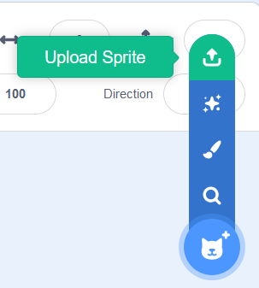
Once the slug is imported you will need to remove the Scratch sprite. Right click on the sprite and select delete...
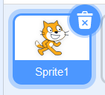
Next make sure that you are happy with the default name for the new sprite...
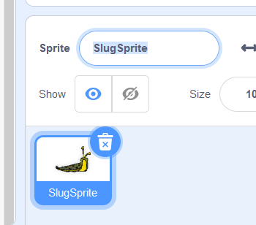
(I can live with that!)

Creating the Racetrack
Please feel free to create your own racetrack in paint or similar, but a sample racetrack has been created for you (again on the module shell).
To upload the track as the background for the stage in a similar manner to the sprite graphic..
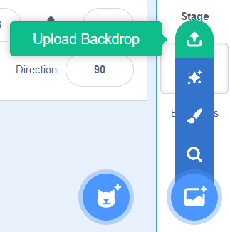

You should see something like this...


Adjusting the Slug Sprite
As things stand there is a big problem with the design, which is the slug is too big to easily navigate around the track. We need to make it smaller.
With the slug sprite selected select the “costumes” tab. This allows you to modify the slug graphic.
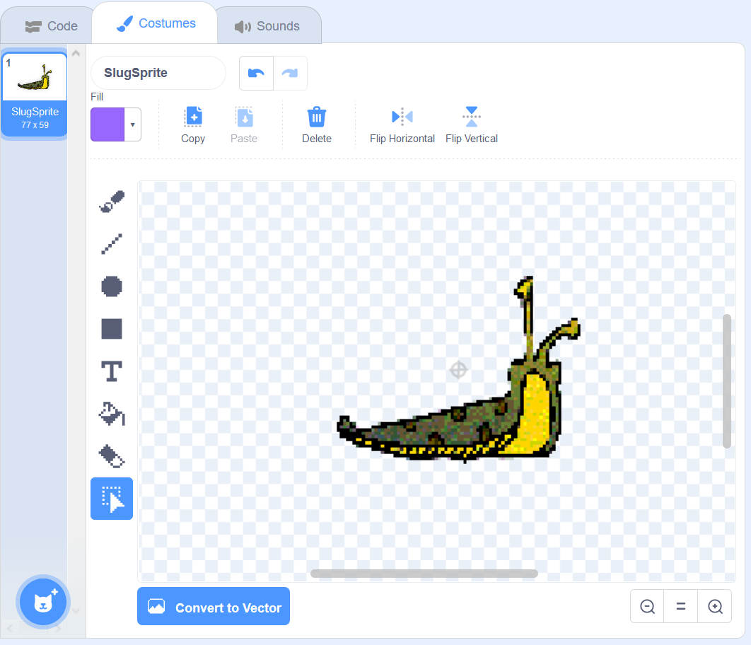
To adjust the size first click the select tool...

To make the slug smaller select the area around it with the left mouse button held down. You should see something like this...
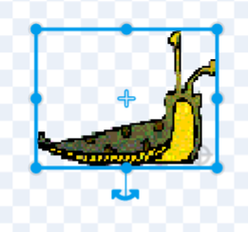
Resize the slug using the square handles indicated by the arrow above.
One thing to notice!
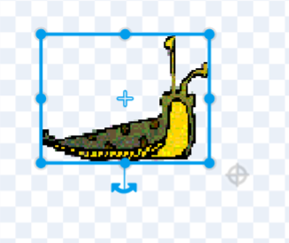
In the example here I have re-sized the slug but note the grey cross in the middle of the hatched area. This cross indicates the middle of the sprite. Notice that the slug has a mark indicated at the centre too.
Most of the time we want these two points to overlap otherwise the movement of the sprite can be unpredictable.
Arrange the two points so that they overlap like so...
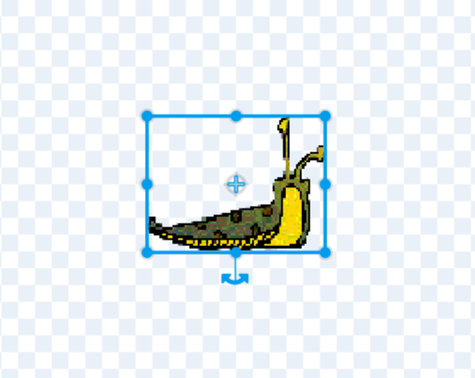
Once the alignment is OK click back on the code tab and the graphic on the stage should update based on the changes you have made...

What you are aiming for is to make the slug small enough to fit around the track giving the user a reasonable chance of not hitting the sides.

Adding the Green Flag
We are now able to start writing the script to make the game work. We shall start with adding an event to make the game start when the green flag is clicked...


Adding the Forever Loop
As the name suggests a forever loop is one that goes on and on – forever!
Available from the control section drag it so that it connects with the green flag event like so...
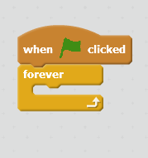
Notice the gap in the structure. This is where most of our commands will be inserted.

Point to Mouse
As the slug travels round the track, we want it to always point at the mouse pointer. To do this, simply add the motion command for point towards mouse like so...
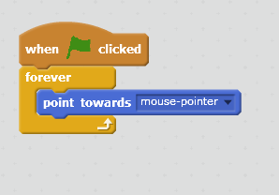
You might like to try testing the script to see what it does. Press the green flag and you should see that the sprite rotates depending on the position of the mouse.

Adding Motion
The next addition to the loop is to make the slug move. Again, this is simple with the addition of move n steps again under motion...
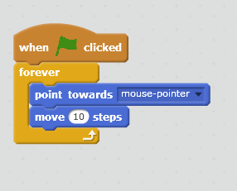
The default is 10 steps but to slow things down click on the number of steps and change it to a value of 1...
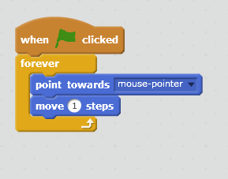
Again, try out the script to see what it does. Not only should the sprite follow the mouse it should now move towards it.

Adding Collision Detection
As things stand nothing happens if the slug hits the side of the track. To add this feature, we will need to make a decision along the lines of “if the slug hits the sides make a sound”.
Under the control section locate the if-then structure and add it to the script like so...
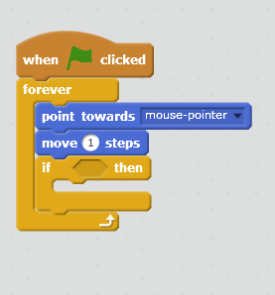
For the if-then structure to make its decision we need to add two features.
- A condition as to when the decision holds true
- An action to carry out once the decision is true
The condition is that the decision is true when the slug hits the edges of the track.
Under the sensing section there are number of instructions for sensing different conditions...
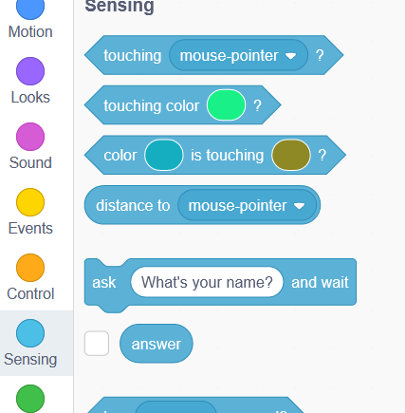
The one we are interested in is “touching color”.
Drag it to the if-then structure such that it docks like so...
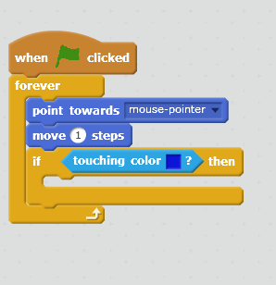
To set the colour we want to detect, click once on the blue square and select the pipette tool  then click once on the colour you want it to detect in the race track. It should now look like this...
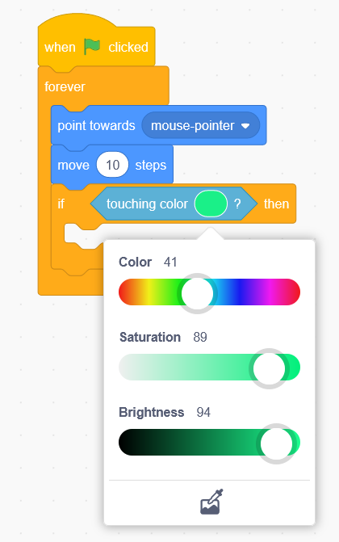
Having set the condition, we now need to set the action.

Importing Sounds
If you flip over to the sound tab, you have the option of importing sound files to play when the slug crashes...
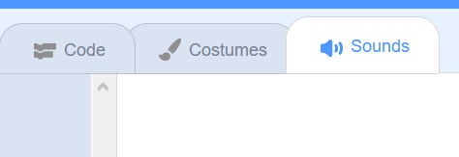
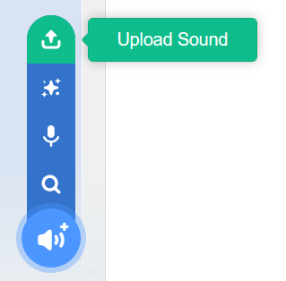
Save the sound file available on the module shell and import it into the project...
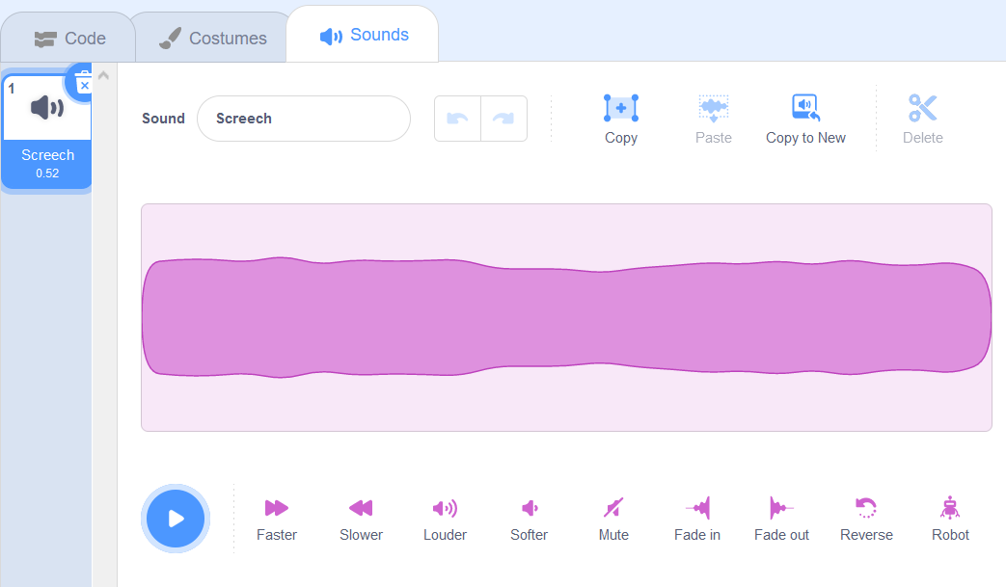
Flip back to the code tab and locate under sound, “play sound”. Modify the script like so...
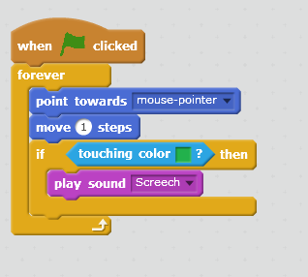
Try the game now, it should be nearly complete.

Adding the Slug Trail
One tool that allows us to draw lines as the sprite moves is the pen.
Under pen select pen-down and modify the script like so...
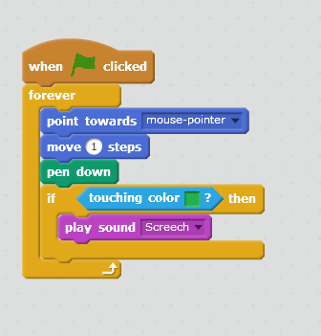
So here is a question. Is that the most efficient place to insert the instruction?
In writing code, we may first have a go at something and then later realise that there is a more efficient way of doing things.
If with the pen it is either “up” or “down” does it make sense to keep putting the pen down all the way through the loop? When writing an algorithm, it is a good idea to not add unnecessary commands where possible. It makes the code less efficient and potentially more confusing. Don’t get hung up either on code being perfect the first time either. This process of refining code is continuous and ongoing.
Look at the following script as a slightly more efficient approach...
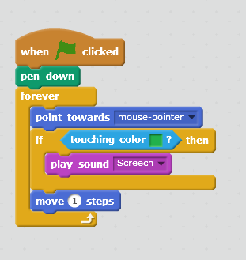
Lastly when we start a new run of the game it might be nice if the slug trail from the previous game was cleared.
The following modification will do this...
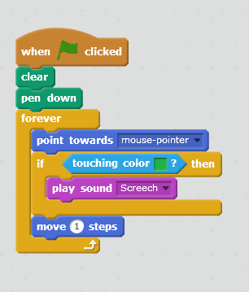

Extensions
Using the on-line sample game and asking the tutor try and see if you can record the number of crashes made by the slug during the game. (Hint you will need to explore the section marked variables.)
The final game should look something like this...
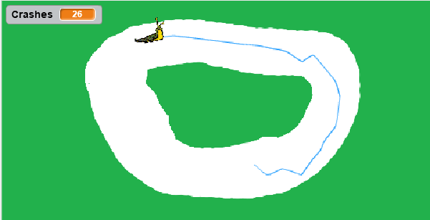

Once completed share a link to your work as a journal entry.

